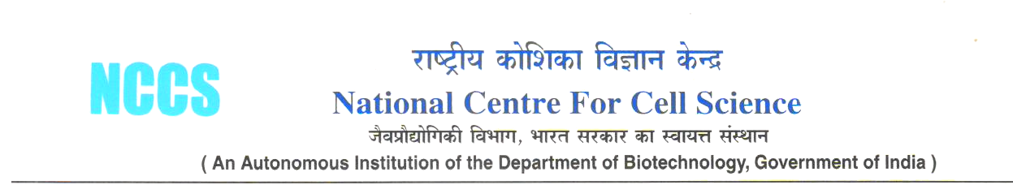

MATERIAL TRANSFER AGREEMENT – NON-PROFIT INSTITUTION

THIS AGREEMENT, entered into on the last date of signature on this Agreement, is between the National Center for Cell Science (NCCS), having a principal office at Ganeshkhind, Pune 411 007, India, Phone: +91-20-25708000 Fax:+91-20-25692259, webpage:www.nccs.res.in and ----------------------, having a principal office at -------------------.. This Agreement governs an arrangement whereby -------------------- of NCCS may make available the Material described below to -------------------------- hereby agree as follows:

1. Material: The Bio-material covered by this Agreement ---------------------------------------and any and all progeny, clones, and modifications to the Material which are based on or incorporate an element of the original Material.

a). Any other relevant information pertaining to this bio-material:: ----------------------

b). Quantity to be transferred: ------------------

c). Purpose and need of transfer of the material: Research and development, non-commercial purpose. -----------------------------

d). Type of research /investigation to be carried out using the material (Please provide a brief outline of the research using the material::

e). The guidelines issued by the MOHFW, GOI vide O>M. No. L.19015/53/97-IH (Pt.) dated 19th November 1997 are to be followed for proposals involving transfer of human biological material for biomedical research purposes.

2. Purpose for Transfer. -------------- will use the Material only for academic research purposes and will not use the Material for any commercial or production purposes. -------------- will not use the Material in any research that is subject to consulting or licensing obligations to any for-profit organizations. No patent / intellectual property issues shall be filed on any product or process so developed using the biomaterial without prior knowledge of the investigator at the sending institute, NCCS.

3. Use of the Material. The material will be provided for basic research only and used only for the purpose defined herein (Section 1d). The Material will not be distributed or transferred to any other investigator or any third party for any reason without the prior written consent of NCCS Scientist. The Material will be used under suitable containment conditions and will not be used in any manner on human subjects. Recipient will not use the Material for any purpose other than the Experiments nor permit them to be used in any way for the production or sale of any products for commercial purposes. The Recipient and the Investigator agree to make correct reference to the work of ---------------------- in all publications which refer to the Materials. ------------ will comply with all applicable laws and regulations concerning the use of the Material, safety norms while working with the bio-material including NIH guidelines.

4. No Warranty. The Material is understood to be experimental in nature and may have hazardous properties. NCCS has made and makes no warranties to -----------------whatsoever regarding the quality of the Material, express or implied, including warranties as to fitness of the Materials for any particular purpose. NCCS further makes no warranty that the Material or use thereof, does not infringe patent or other intellectual property rights of others.

5. Hold Harmless. To the extent permitted by applicable law, --------------- will hold NCCS harmless from and be responsible for any liability for, and will defend NCCS from any claims or damages, including attorneys fees, resulting from, arising out of or in any way relating to ----------------- use of the Material, except for any such claims or damages arising out of gross negligence, recklessness, or willful misconduct of NCCS.

6. Return of Material. At the request of NCCS or NCCS Scientist, unused Material received from NCCS will be promptly returned or destroyed.

The parties to this Agreement, NCCS and--------------, hereby indicate their agreement to the terms of this Agreement by affixing the signature below of an appropriate representative or officer who is specifically authorized to execute documents of this type.

The provider The recipient
I represent that I have legal authority to execute I represent that I have legal authority to execute
this agreement on behalf NCCS this agreement on behalf of ---------

NCCS --------------
By: By:
Name: Name:
Title: Title: Director
Date: Date: 13.4.2008

NCCS Scientist and ------------- Scientist, by affixing their signatures below, acknowledge that they have read and understood the terms of this Agreement.

NCCS Scientist Principal Investigator
By: By:
Name: Name:
Title: Title:
Date: Date: .

